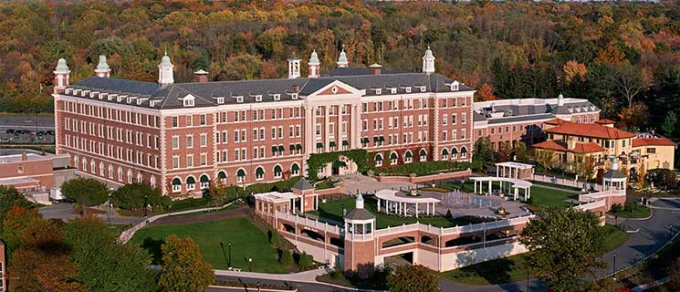 **The Culinary Institute of America, 1946 Campus Drive, Hyde Park, MY 12538**

**“Educational Tour, Lunch and Learn” Co-sponsored by PBAC & AHFNY**

**Date: 10/20/2023**

**Going: St Albans Commissary Parking lot 8AM sharp**

**Coming back: Leaving CIA 2PM---Stop over Stew Leonard’s Fresh Farm Food & Wine, Yonkers, NY---Arrival to St Albans approximately 6PM**

**Price including CIA tour, lunch at American Bounty Restaurant & coupon to gift shop.**

**Total package value $ 125 with 4 CEU requested for RDN & CDM (seats are limited and registration is not -refundable)**

**AHFNY Operator members: $50 each**

**Facility Non- member or guest: $125 each including 2023 AHFNY membership**

**Business Partner Board members only: $80 each**

**Menu: 1. First course:  ARUGULA SALAD -Roasted Marinated Baby Beets, Spicy Pecans, Poppy Seed Vinaigrette**

1. **Main course: PAN ROASTED SEA BASS-Grilled Vegetables, Caper Vinaigrette**
2. **Dessert: MASCARPONE CHEESE -Graham Cracker Short Bread, Blood Orange Sorbet, Cocoa Nib Tuile**
3. **Coffee or tea**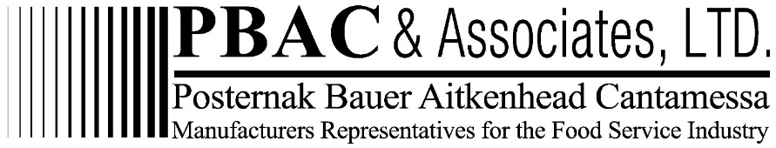

**Register by click:** [**https://ahfny.org/events.aspx**](https://ahfny.org/events.aspx) **or write check to: AHFNY then mail to Mimi Wang, 225 Cherry Street, Apt. 52D, NY, NY 10002**